PRODUCT SPECIFICATION SHEET:

Fire-extinguishing platform for cooling of electric cars

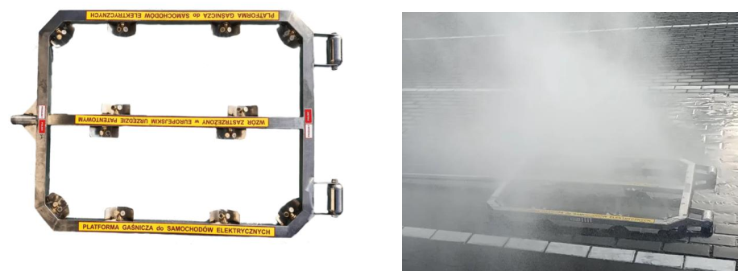



|  |  |
| --- | --- |
| **Main features and parameters**   * Designed for cooling and extinguishing of battery cells in electric cars, * Adjusted for working pressure of max 8 bar * The platform can be fed through a W-25 or a W-52 hose after using a 52/25 adapter * Relatively small size of 77cmx100cm and a height of only 5cm, which allows being insert under very low cars * For the safety of the rescuer, the set includes extensions made from a stainless pipe (3 sections, 1.2 [m] each) ended with a ball valve.   the used filters prevent the water nozzles from dirt | **Elements of the platform**  Fully made of a stainless material that is resistant to high temperatures  The extension with a ball valve includes an integrated filter that prevents dirt from getting into water nozzles from the tank of the fire truck; what is more, it can be cleaned after operation  12 dual brass nozzles, additionally protected against mechanical damage with a stainless bracket  The platform features stainless rollers that facilitate placing the device under the vehicle |